**Object Oriented Programming**

**Lab report: 7**



|  |  |
| --- | --- |
| Name | Ali Salman |
| Reg no | FA22-BCE-005 |
| Class | BCE- 4 |
| Instructor’s Name | Prof. Tayyab Rasul |

**Lab 09 – *Composition / Containership***

**Lab Tasks**

**5.1.**

**Program:**

**Classes:**

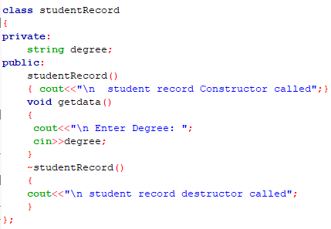

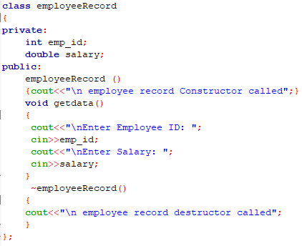

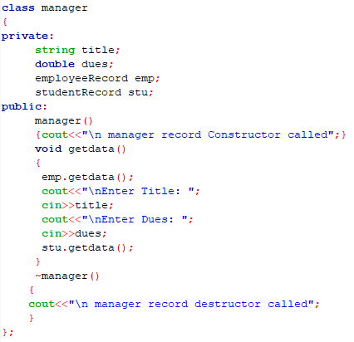

**Main:**

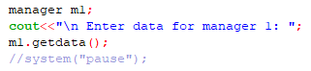

**Output:**

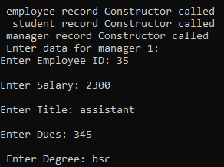



**5.2.**

**Program:**

**Classes:**

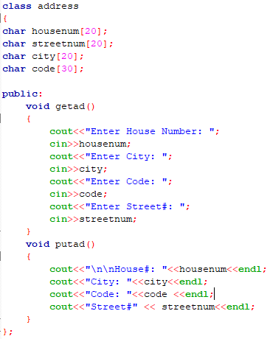

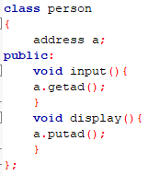

**Main:**

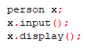

**Output:**

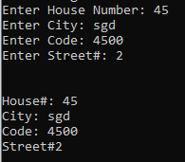

**5.3.**

**Program:**

**Classes:**

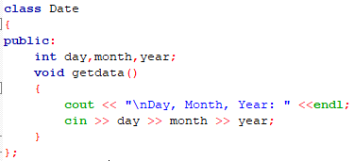

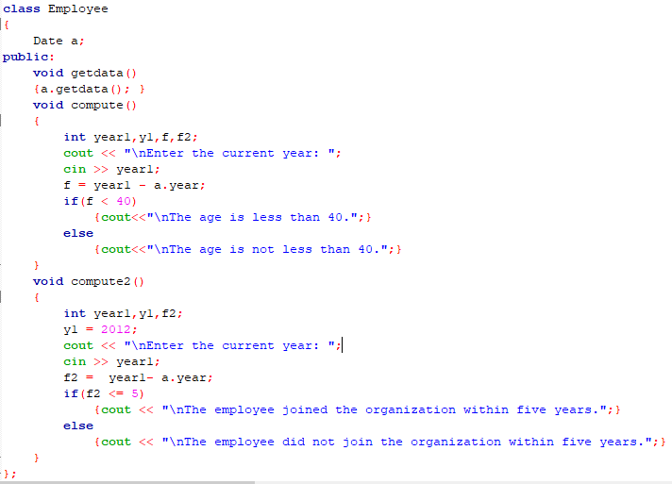

**Main:**

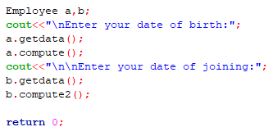

**Output:**

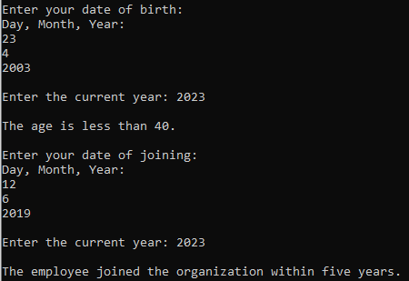

**Home Tasks**

**Program:**

**Main:**

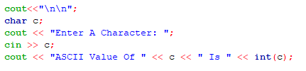

**Output:**



**Critical Analysis:**

In this lab we learn about the concept of containership, in which object of one class is created in another class and the object is the member of that class. This concept is used when we need the features of one class into another class without its interference. In this way we can excess the member functions of a class without extending the logic of a class.